**Multimedia & Graphics**

**Class Six**

**Lab 13**

|  |
| --- |
| Lab Objectives:Introduction to Photo Editing |

# What is Photo Editing

The meaning of photo editing is the act of altering an image, simply put. But that’s oversimplifying a subject which is quite complex.

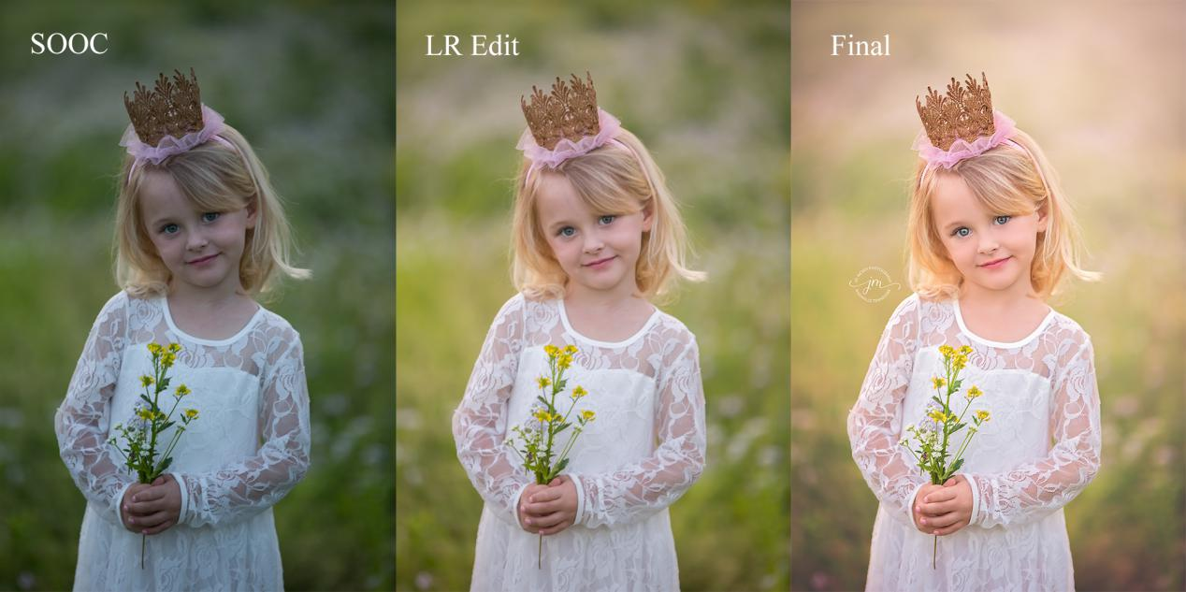For example, some photo editing techniques are done manually, while others are conducted through automated software.

Some photo editing is even done offline, on actual photographs, posters or other printed collateral.

## Other terms for photo editing:

## Image editing

## Post-processing

## Image/photo manipulation

## Image/photo enhancement

# What are the different types of photo editing?

## There are many different types of photo editing. Some are simple and others are more complex.

## You can typically execute simple photo-editing techniques fairly easily and quickly. Complex techniques and digital editing may require a software program and more experience and training.

# Simple photo-editing techniques include:

## Noise reduction: smoothing the picture out, typically accomplished by reducing the pixel size

## IMG_256

## White balance: the color of the light in the image

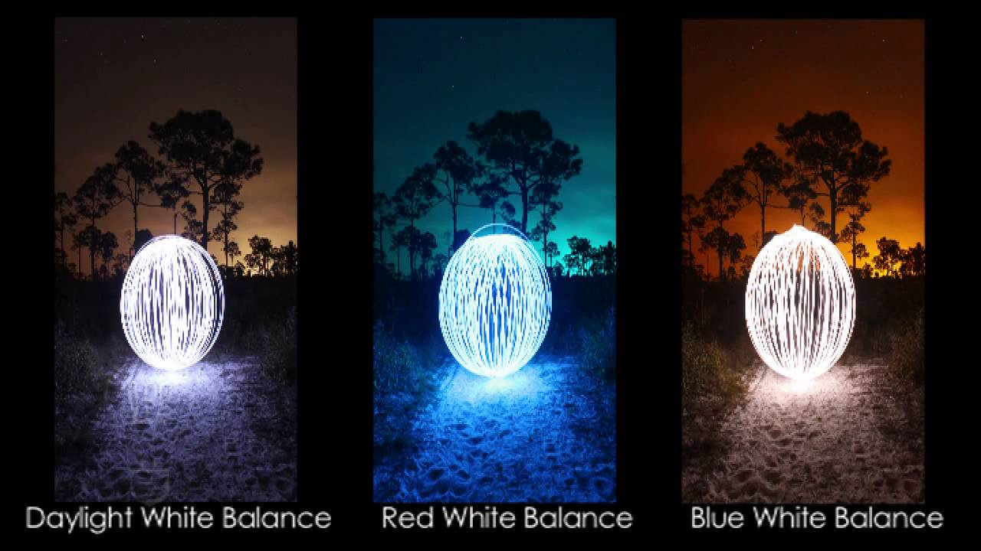

## Contrast: higher contrast makes an image more punchy, while lower contrast makes it flatter in color

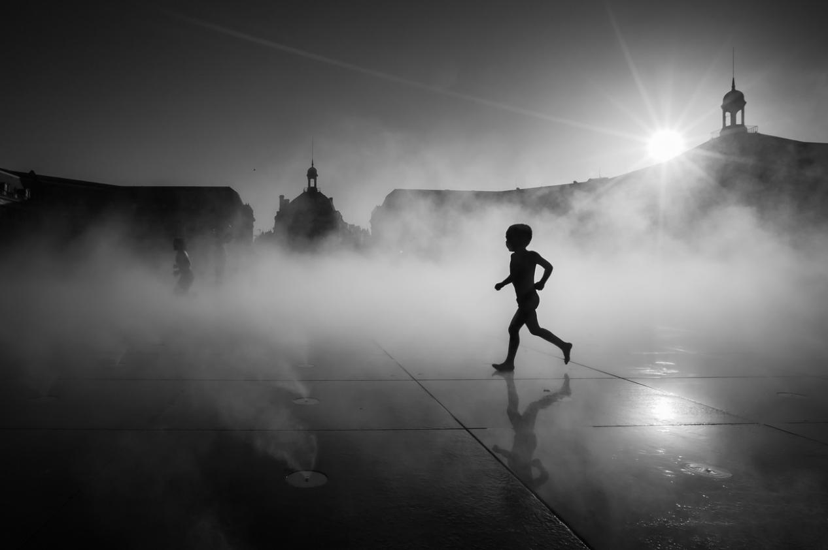

## Exposure: the brightness of the photo

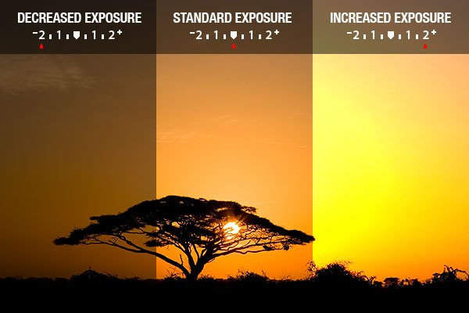

## Lens correction: addresses any issues with the camera lens

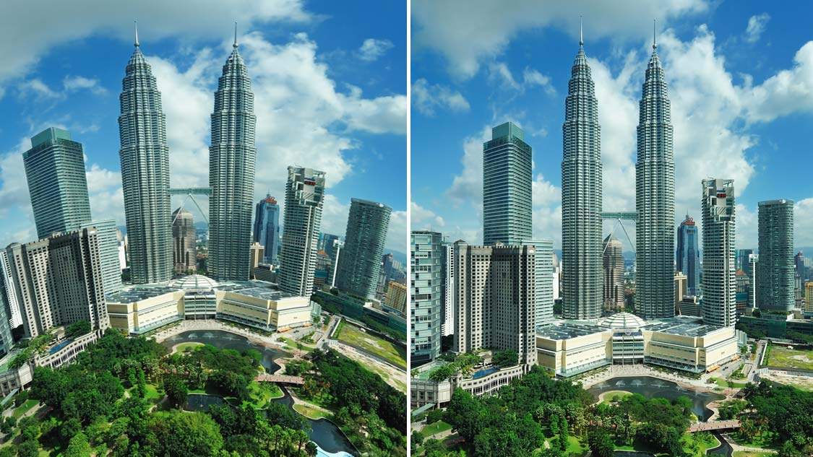

## Color adjustments: change the color of an item or element in the photo

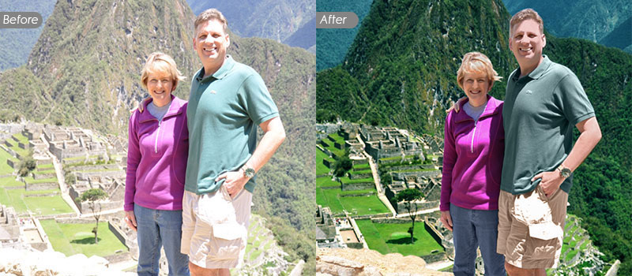

## Resizing and cropping: adjust the dimensions of the image

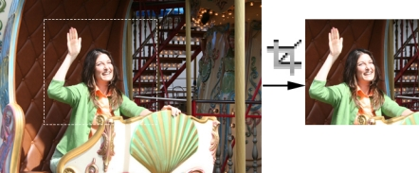

## [Background removal:](https://clippingpathindia.com/pages/background-removal) delete the background from the image, isolating the subject (this is often used for white background product photography)

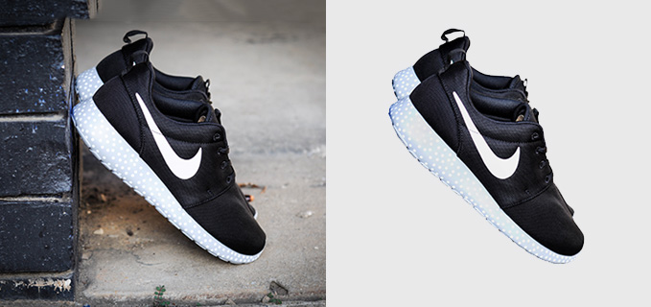

# What is photo-editing software?

## The tools which you can use to edit or manipulate images.

## To make this easier, editors use photo-editing software programs. There are many kinds of photo-editing software, each with its own costs, features and pros/cons.

# Popular photo-editing software and programs

## [Adobe Photoshop](https://www.adobe.com/products/photoshopfamily.html" \t "/home/deepto/Documents\\x/_blank)

## [Serif Affinity Photo](https://affinity.serif.com/en-gb/photo/" \t "/home/deepto/Documents\\x/_blank)

## [Pixlr](https://pixlr.com/" \t "/home/deepto/Documents\\x/_blank)

## [Aviary](https://aviary.com/" \t "/home/deepto/Documents\\x/_blank)

## [Canva](https://www.canva.com/" \t "/home/deepto/Documents\\x/_blank)

## [GIMP](https://www.gimp.org/" \t "/home/deepto/Documents\\x/_blank)

## [Microsoft Paint](https://ms-paint.en.softonic.com/" \t "/home/deepto/Documents\\x/_blank)

## Sketchpad

### Popular photo-editing mobile apps:

## [Snapseed](https://itunes.apple.com/us/app/snapseed/id439438619?mt=8" \t "/home/deepto/Documents\\x/_blank)

## [VSCO](https://vsco.co/" \t "/home/deepto/Documents\\x/_blank)

## [Afterlight](https://afterlight.co/" \t "/home/deepto/Documents\\x/_blank)

## [Instagram](https://www.instagram.com/" \t "/home/deepto/Documents\\x/_blank)

## [Enlight Photofox](http://www.photofoxapp.com/" \t "/home/deepto/Documents\\x/_blank)

## From the next lab you will learn step by step photo editing and graphics design with sketchpad. Sketchpad is an online painting tool.

